**Table of Contents**

**Modifying Web Hosting Code Files for HEROES for Students** 2

**Putting photos into Homepage Slideshow** 5

**Changing animation/video files and photo captions in What We Do page** 7

**Changing Values paragraphs in What We Do page** 9

**Updating Board of Advisors photos and text** 10

**Updating News Feed links** 11

**Modifying Web Hosting Code Files for HEROES for Students**

**Step 1:** Logon to GoDaddy.com account with username and password.

**Step 2:** At **'My Account'** page under the **'Products**' tab click on the green **'Manage'** button that is to the right of the **'Web Hosting'** section.

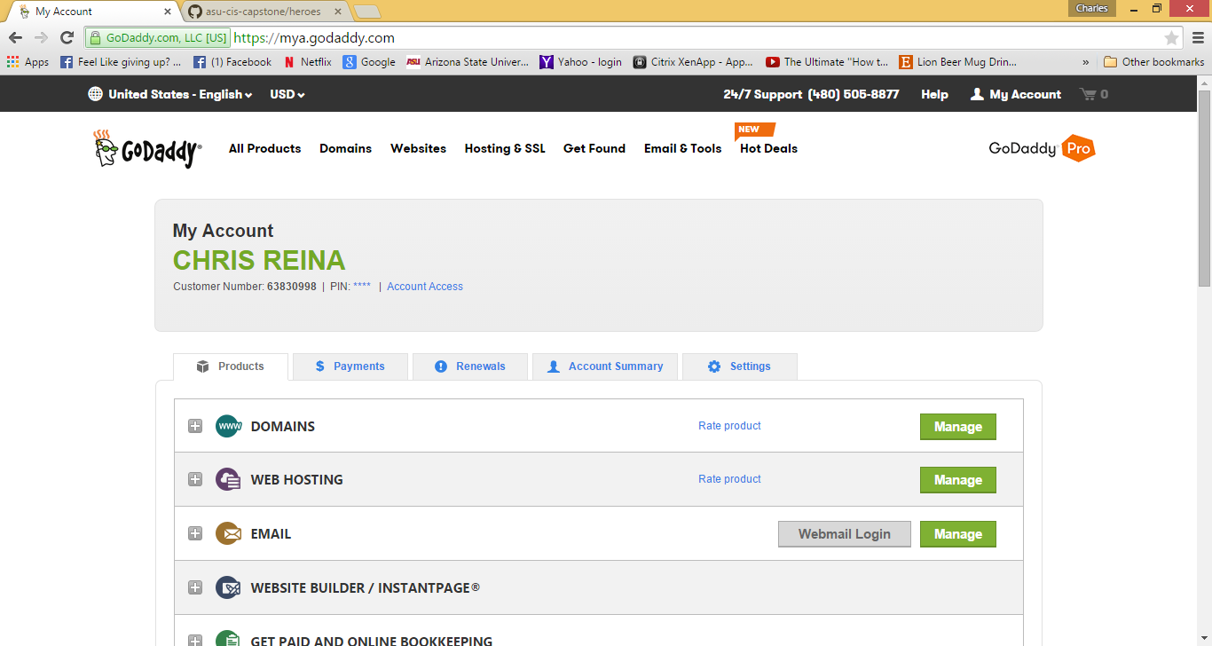

**Step 3:** At the next page there will be another **'Manage'** button. Press the Manage button.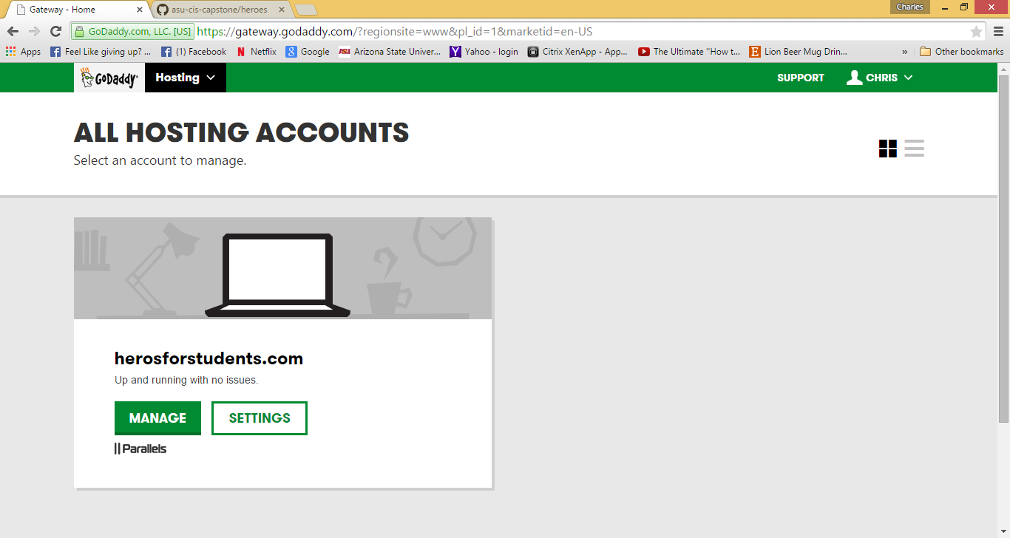

**Step 4:** At the **'Website & Domains'** page chose a website/domain section and click on the **'File Manager'** link or the **'Open Site'** button located in the lower left quadrant of that domain's section.

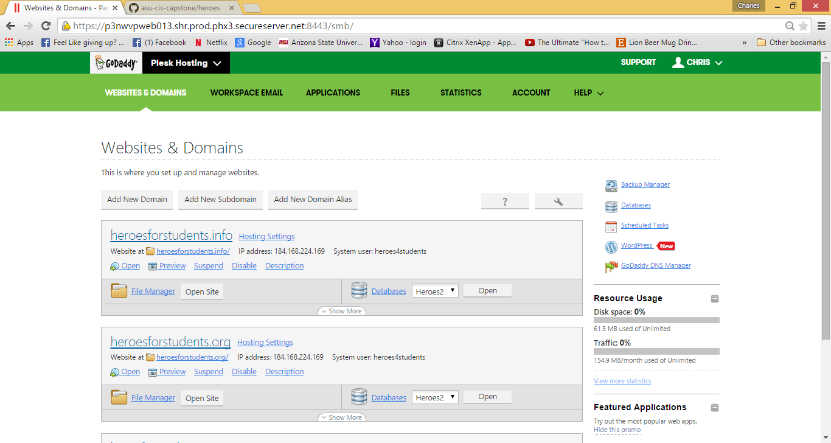

You should now be viewing the **File Manager** page. All folders and files are located here. You can change code in files using the **Code Editor**.

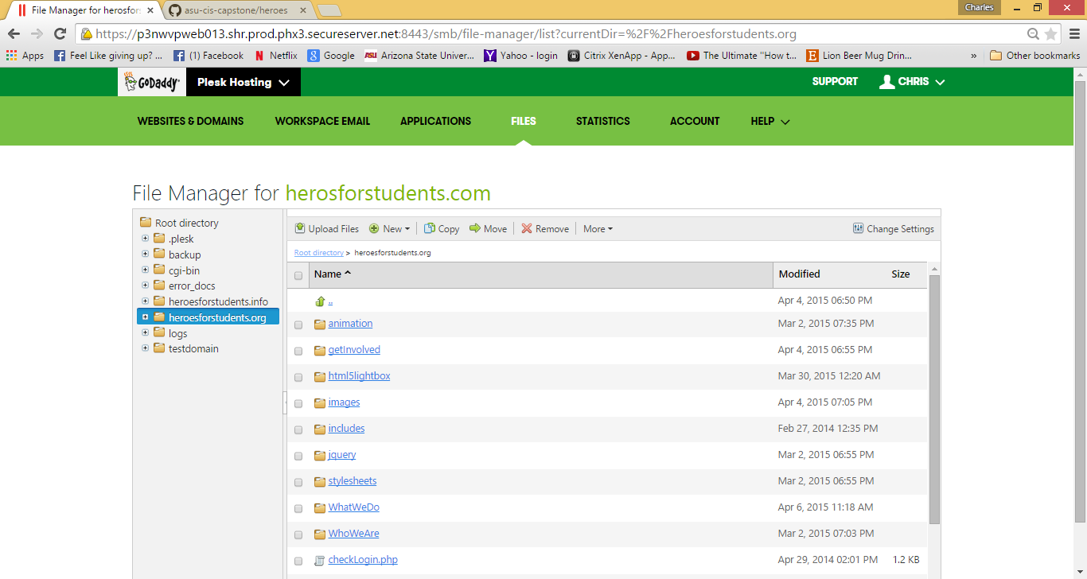

**Step 5:** You can access the **Code Editor** by going to the far left side of the file and in the area right before the timestamp where a down arrow in a circle will appear. You can click that and a menu will appear. The top selection of the menu is for the **Code Editor**.

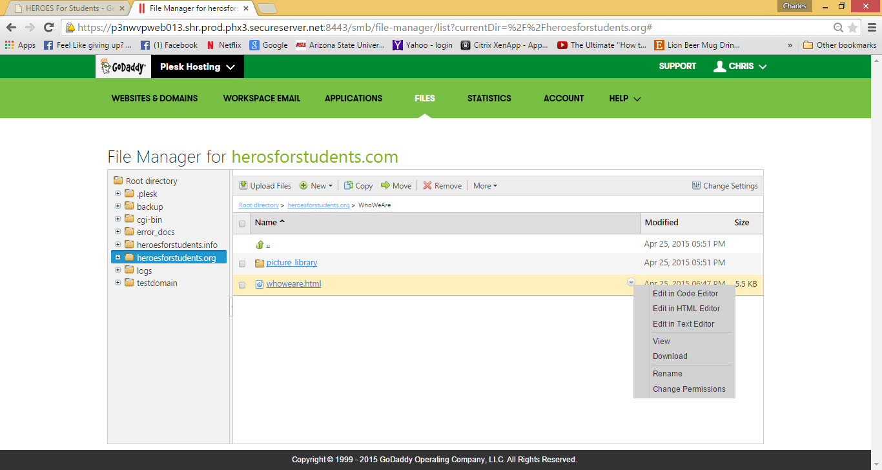

**Putting photos into Homepage Slideshow**

You can change or post new photos into the homepage for Heroes for Students by accessing the **Code Editor** for the **index** file found on the **File Manager** page. See **Step 5** for **Modifying Web Hosting Code Files for HEROES for Students** for process of accessing the **Code Editor**. 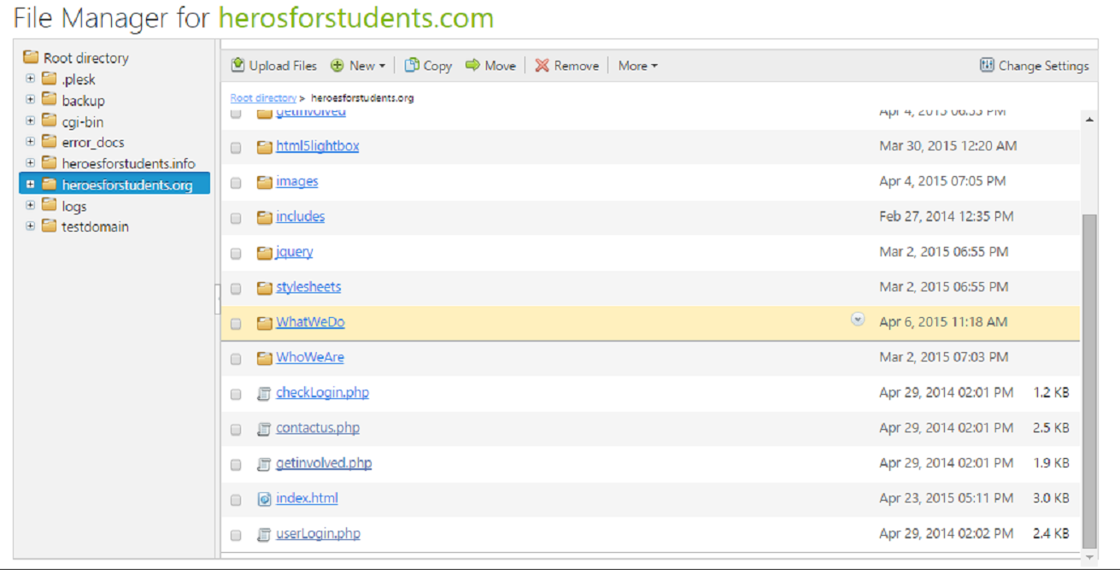

In the **index** file find the **‘main’** div. Observe that there are images (jpg, png, etc.) in another div called ‘**slideShowImages’** within the **main** div. You can either change the images by changing the image name and file extension or you may add more photos to the slide show by simply copying and pasting an image line (ie. Copy the whole line and paste it in-between the div tags. See bracket.) and changing the file name and extension to a new one.

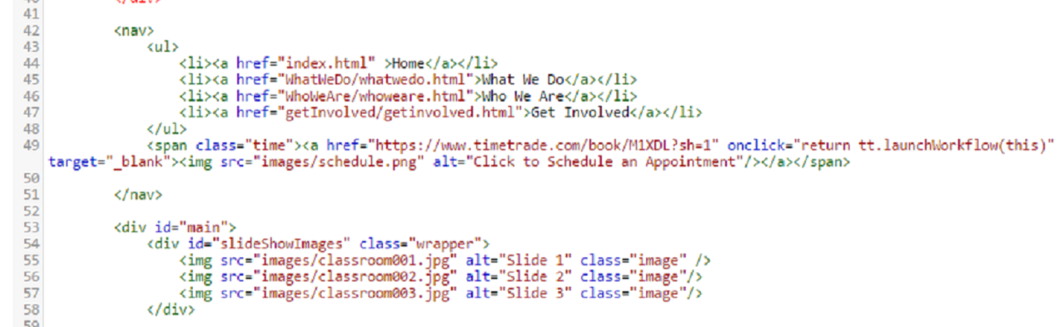

**Note**: You can add as many images as you like as long as they are in-between the **div** tags.

**Example of changing an image in the Slideshow:**

Change ‘**<img src=”images/classroom003.jpg” alt=”Slide 3” class=”image”/>**’ to

‘**<img src=”images/classlecture.png” alt=”Slide 3” class=”image”/>**’

**Example of adding an image to the Slideshow:**

Copy any line (ie. ‘**<img src=”images/classroom003.jpg” alt=”Slide 3” class=”image”/>**’) and paste onto the line below it after first creating space (by pressing enter after the last image tag). Then proceed to change the path/file name to the image you wish to add. **Only change the file name & extension** as all images should be uploaded to the ‘**images’** folder in **File Manager**.

**<img src=”images/ classroom001.jpg” alt=”Slide 1” class=”image”/>**

**<img src=”images/ classroom002.jpg” alt=”Slide 2” class=”image”/>**

**<img src=”images/ classroom003.jpg” alt=”Slide 3” class=”image”/> 🡨Copied line**

**<img src=”images/ classroom004.jpg” alt=”Slide 4” class=”image”/> 🡨 Pasted and altered line**

**</div>**

**Changing animation/video files and photo captions in What We Do page**

Using the **Code Editor,** access the **whatwedo.html** file and go to the **‘multi’** div. Inside the div is a ul class called ‘**photo-grid**.’ You can change the video link by changing the **href** video link. **Note**: This video can be at a http location or a file path location. **ONLY CHANGE THE HREF**.

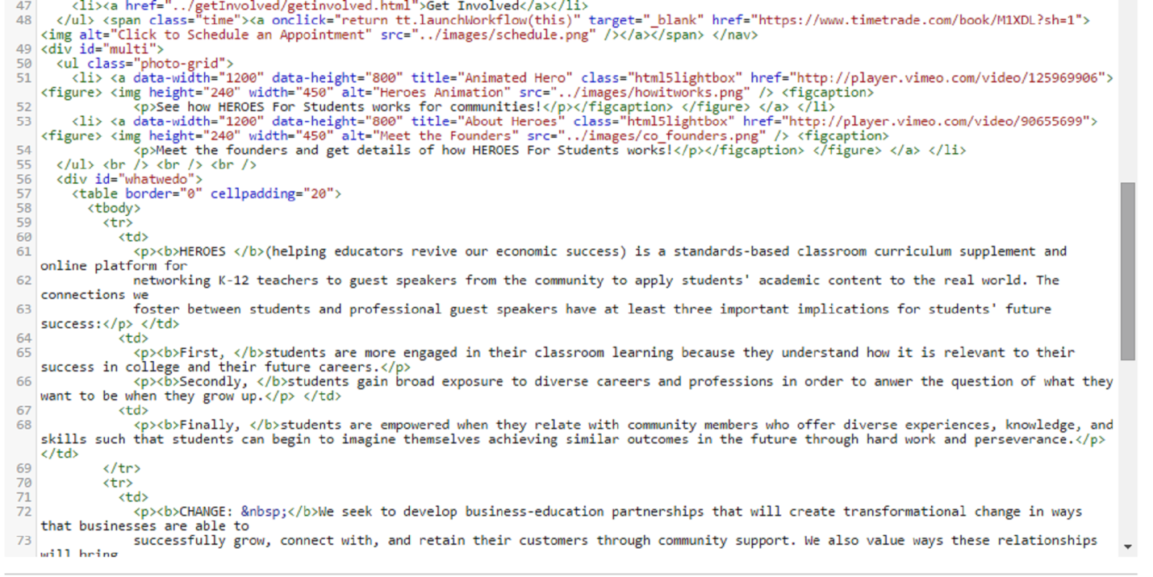

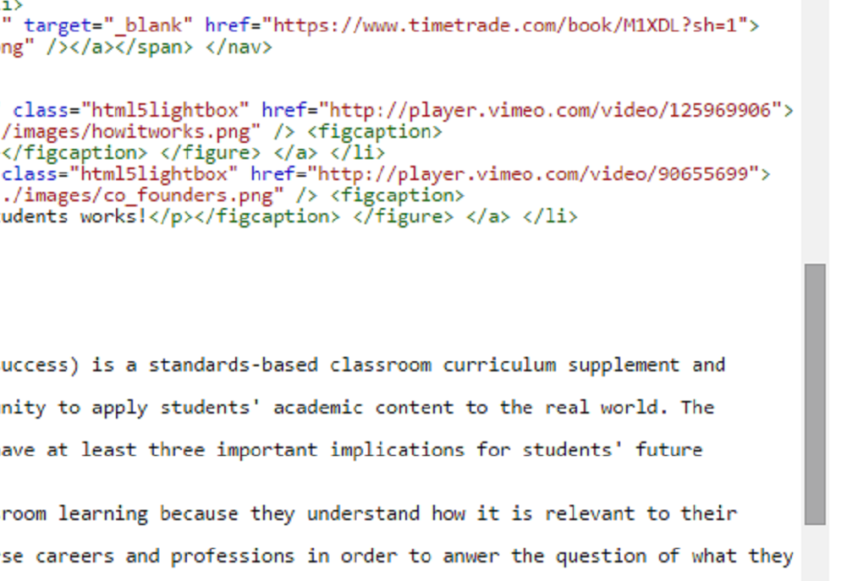

You can change the image that shows for the videos by adding the image of your choice and changing the path of the **src** to point to the image in the ‘**image**’ folder.

To change the caption that appears when you hover over the photo image change the text in the paragraph tag **<p>**.

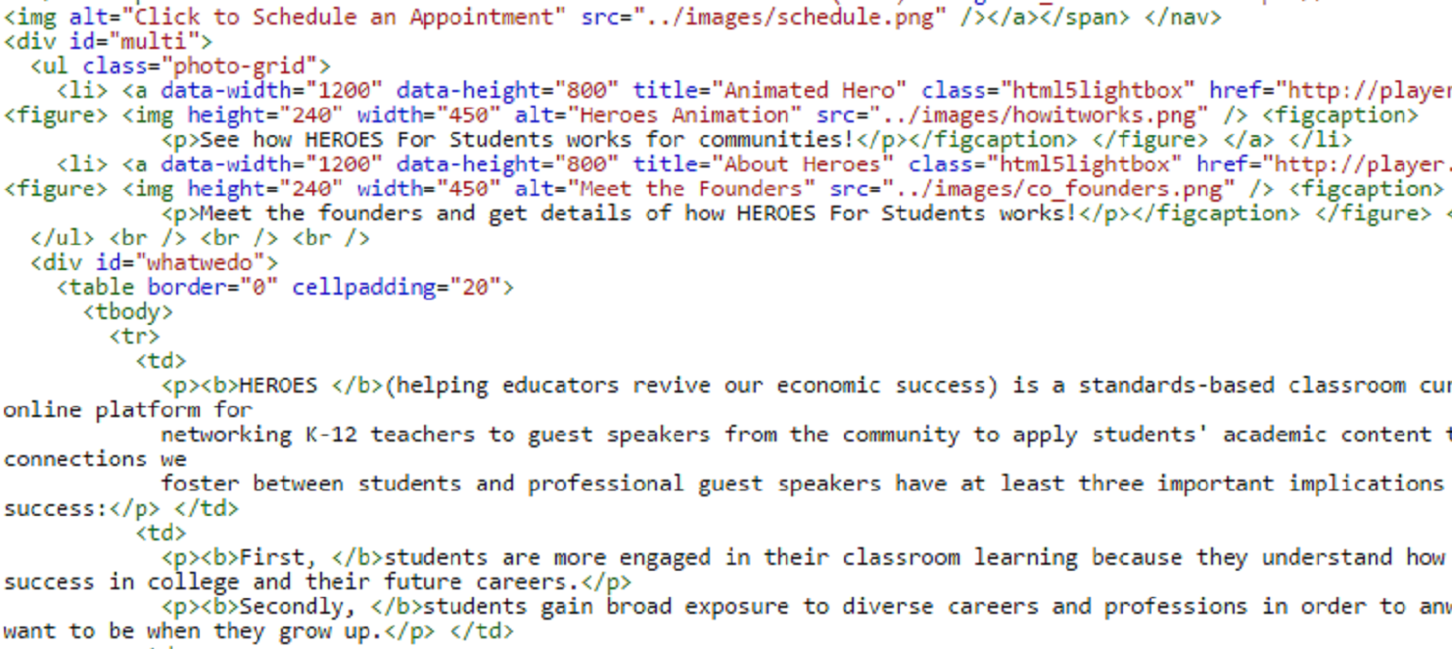

**Changing Values paragraphs in What We Do page**

To change the text for any of the HEROES values just access the **whatwedo** file via the **Code Editor** and change the text in the **Code Editor** directly.

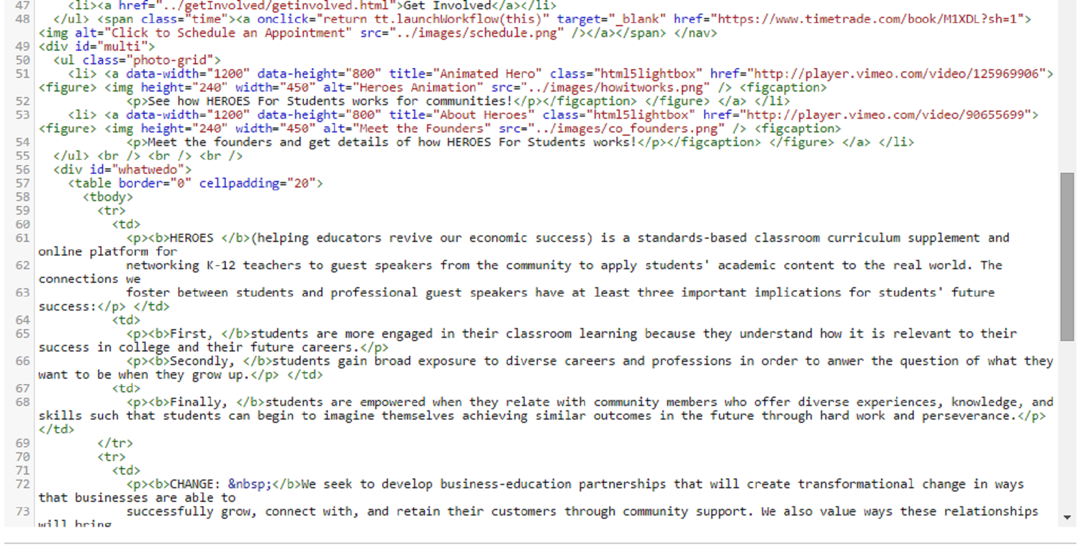

**Updating Board of Advisors photos and text**

To change a photo for a member of the Board of Advisors on the **Who We Are** page go to the folder in **File Manager** and access the whoweare file via the **Code Editor** and change the image in the code under the *table class* called **“advisors.”** The only code that will be altered is the name and extension of the image file for whichever person is being replaced.

**Example:**

<td id="container"><img id="image" src="../images/kendrick.jpg" /><p id="text">Kendrick Bates</p></td> **🡨 old**

<td id="container"><img id="image" src="../images/stacey.jpg" /><p id="text">Stacey Brooks</p></td> **🡨updated**

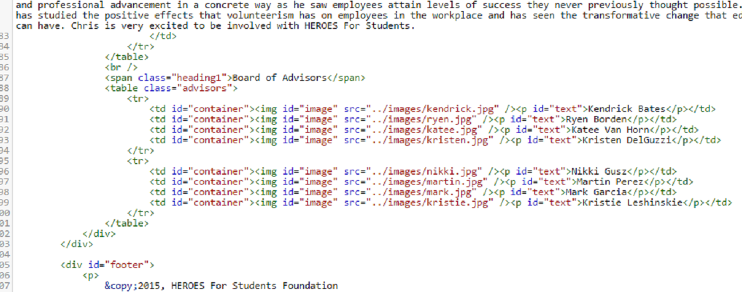

In the case that more members are added to the Board of Advisors another table (**<tr>**)will need to be created. To create another row for photos copy the whole section of the table.

**Example:**

Copy all of the code as seen below and paste the code below the bottom table code. The code should be pasted between the **</tr>** tag and the **</table>** tag. Edit the photo files and text as needed. Any containers that are not being used may be left blank (**src =””**)

<tr>

<td id="container"><img id="image" src="../images/nikki.jpg" /><p id="text">Nikki Gusz</p></td>

<td id="container"><img id="image" src="../images/martin.jpg" /><p id="text">Martin Perez</p></td>

<td id="container"><img id="image" src="../images/mark.jpg" /><p id="text">Mark Garcia</p></td>

<td id="container"><img id="image" src="../images/kristie.jpg" /><p id="text">Kristie Leshinskie</p></td>

</tr>

**Updating News Feed links**

To change links for the News Feed on the home page access the index.html file on the **File Manager** page using **Code Editor**. Go to the table **id** “newsfeed” and change the **href** link of the appropriate table to reflect the URL that you want it to point to. Also, change the caption that comes after the **href** link and the date to whatever date the article has on the URL listed.

